**PROJECT REPORT ON**

**“PORTFOLIFY – Your Portfolio Builder”**

Submitted to

Savitribai Phule Pune University

In partial fulfilment of the requirements

for the degree of

**Bachelor of Science in Computer Science**

by

Mohammed Taherali 6403

**Under the Guidance of**

Prof. Sanket Lodha



**Department of Computer Science**

**Vishwakarma College of Arts Commerce and Science**

**Savitribai Phule Pune University**

**AY 2023-2024**



**Department of Computer Science**

**CERTIFICATE**

This is to certify that Mr. Mohammed Taherali has satisfactorily completed project titled **PORTFOLIFY – Your Portfolio Builder**for **BSc. Computer Science** for academic year 2023-2024.

Project Guide Head of the Department Principal

(Prof. Sanket Lodha) (Prof. Sudhir Chitnis) (Dr.ArunPatil)

Internal Examiner External Examiner

**DECLARATION**

I declare that this written submission represents my ideas in my own words and where other’s ideas or words included; I have adequately cited and referenced the original sources. I also declare that I have adhered to all principles of academic honesty integrity and have not misrepresented or fabricated or falsified any idea+data+fact+source in my submission. I understand that any violation of the above will be cause for disciplinary action by the Institute and can also evoke penal action from the sources which have thus not been properly cited or from whom proper permission has not been taken when needed.

Mohammed Taherali (6403)

**ACKNOWLEDGEMENT**

At the outset of this project I would like to express my profound thanks to few people without whose help, the completion of this project would not have been possible.

Discussions with fellow students improved my understanding and led me to revise my views on more than one occasion. I am very grateful to Prof. Sanket Lodha for being excellent mentor and helping me whenever I approached him and for walking me through the semester.

Last but not least I would like to thank my parents for supporting me financially and emotionally during this time.

**Abstract**

This thesis project consists of the development of an aesthetically pleasing portfolio building website to help beginners and veterans alike to build their professional portfolio as well as providing guidance to make one with detailed instructions as to what is suitable to enter in specific fields with proper examples about what to write so as to successfully guide beginners to make their new and professional portfolio.

This is important because with the new digital age having a digital introduction of yourself, your skills, achievements, degrees, education and so on makes it really convenient to use rather than having to introduce yourself personally or to use paper to send introduction as per needed. Portfolio is better than both in many ways, some of being not needed to be present to introduce oneself, anyone that you share your portfolio to will be able to get your introduction without the need of pen and paper and it will even be instantaneous thanks to the advancements in technology allowing for rapid sharing of information.

This website is made using HTML, CSS and JavaScript on the frontend and PHP in the backend. MySQL is used for storing data and portfolios and hosting is provided by IIS Server for extreme reliability.

The primary objective is to attract creative professionals and students looking to showcase their work. Our features include:

* Creating and editing portfolios.
* Considerably large collection of templates.

The end goals and future enhancements of this project include:

* Increasing the amount of templates to encourage flexibility in making one’s portfolio.
* Transforming the UI for a seamless experience and welcoming interface for the user.
* Attracting stakeholders and investors to further our website financially and technically.
* Increasing the UI friendliness of the website.
* Making the website optimized for mobile devices.
* Adding more templates for freedom of choice.
* Adding fonts to change the way a portfolio looks.
* Making sure the website is safe from DDOS attacks by purchasing services such as Cloudflare which mostly prevent DDOS attacks.
* Adding a human verification such as CAPTCHA to prevent bot raids.
* Increasing the responsiveness of the website.
* Increasing load speed by cleaning and optimizing codes.
* Solidifying our Database to welcome any amount of data for storage.
* Providing contact information in case of discrepancy.

|  |  |  |
| --- | --- | --- |
| **INDEX** | | |
| **Sr.no.** | **Topic Name** | **Page No** |
| 1. | **Introduction**  Motivation  Existing System  Need for New System  Problem Definition and Scope  Purpose/objective and goals  Literature survey | 2  4  6  8  9  11  12 |
| 2. | **System Analysis**  Existing system  Proposedsystem and features  Methodology used  Stakeholders  Requirement analysis | 13  13  15  17  19  20 |
| 3. | **System Design**  Feasibility Study  System model: Using OOSE | 21  21  22 |
| 4. | **Diagrams**  System Flow Diagram  Activity Diagram  Sequence Diagram  Use Case Diagram  Package Diagram  ER Diagram  Data Flow Diagram  Database Designing  Screen Designing | 23  23  25  29  30  31  32  33  37  39 |
| 5. | **Implementation details**  Hardware and Software Requirement | 48  48 |
| 6. | **Outputs and Reports Testing**  Black box testing  White box testing  Test Scope | 49  49  51  52 |
| 7. | **Conclusion**  Limitation  Purposed Enhancements | 55  56  57 |
| 8. | **Future scope** | 58 |
| 9. | **Bibliography** | 59 |

**Portfolify**

**Your Portfolio Builder**

**1.INTRODUCTION**

Since old times casting an elegant and good first impression has been extremely important, huge decisions and opportunities have been bestowed upon only those who have been worthy be it choosing a general who will lead the country to victory, the next CEO of the company, or even as small as doing a trivial task, making first impressions go well can significantly increase a person’s standing, while the other gauge the personality, reliability, and overall character of the person.

Especially in these days where companies are only hiring people while being short-handed and short of time, casting an extraordinary first impression is of utmost importance, but since in these times digital information is much more prevalent, making use of a portfolio to present yourself to others from around the world is much easier. A portfolio is defined as a well-defined collection of documents, photographs, education, work achievements, and other evidence of your work.

With a portfolio, a person is attracted to the properly designed introductions, and well formatted displays of your achievements which is a must since people would not want to look at a mess of an introduction. The more proper it is, the better it is. This could significantly affect your first introduction positively. As the adage says “**First impression is the last impression**” which holds true till this day standing the test of time. Therefore making an exquisite portfolio is of the utmost importance causing all sorts of people to look at your portfolio and even gaining a chance at a job opportunity.

Due to this advancement in technology, digital introductions are necessary, a hole filled by building a portfolio which our website with a beautifully crafted UI guides users into making an attractive, proper, and formatted portfolio that they can download locally. A portfolio is very versatile as it can be edited on the fly, and sent to be viewed digitally removing the need for a hard copy and giving a proper insight into the person’s background, effectively making it, in all ways advantageous to traditional hardcopies.

A few key advantages of making a portfolio are:

* A neat and detailed introduction to yourself.
* Attracts job opportunities.
* Casts an amazing impression to the viewer.
* Eliminates the need for using paper effectively being helpful to the globe but also being easier to edit as compared to hardcopies.
* No waiting for sharing of portfolio, modern technology makes instantaneous and rapid sharing of files possible as compared to traditional hardcopies.
* Combines all your important information into a single place therefore being convenient.

The above few points perfectly explain the need and proper use for portfolios. They are undeniably the introductions of the future. The advantages aren’t limited to the ones stated above, as technology progresses the process of making a portfolio will be redesigned, opening up new spaces for improvements, overhauls, and enhancements which will help make portfolios even more desirable.

Embracing the new digital age is necessary as it brings many advantages with positive points far outweighing the negative ones.

**MOTIVATION**

The motivation for this project came through the messy use of paper or the use of verbal communication to introduce oneself.

The use of paper to introduce oneself can be messy depending on one’s placement of sections, use of words and of course handwriting which can lead to illegible letters, not to mention using papers causes deforestation, which made us realise to pursue a project that emphasises on the use of digital communication to introduce oneself.

By using verbal communication to introduce oneself, being present is a necessity, and along with that people tend to forget all the details they wanted to share to the person they’re having a conversation with, possibly through nervousness or just forgetting to include it with them.

With the help of a portfolio one can easily make an introduction to themselves by using the technological advancements, with this there is no longer the need to use paper or even verbal communication to introduce yourself to others and also eliminates the possibility of losing out important details.

You can take as much time as you need to build a portfolio which can help you get better known by others.

But looking at some websites we saw that they don’t clearly describe what is supposed to be written, we can’t expect new beginners to know jargons.

Therefore we as a team considered to build a project of building a portfolio which we aim to make as user-friendly as possible complete with tutorials, examples and hints for ease of use and accessibility considerably enhancing a user’s experience in building a portfolio.

The advantages of portfolio are:

* Portfolios are easy to design.
* Portfolios give a proper introduction to a person.
* Portfolios can be done in various templates retaining a singular easy to understand format
* Portfolios open up new job opportunities as it is digital anyone can view it and select a candidate.
* Sends a good impression of the writer to the viewer.
* Properly built portfolios make a person appear professional.
* Portfolios don’t need a person to appear personally removing the need for physical presence.
* As portfolios are digital they cannot wear down like papers or cardboards and remain in pristine condition.

**EXISTING SYSTEM**

The existing system consists of the following options:

1. Writing down your introduction
2. Verbally introducing yourself
3. Writing an E-Mail

Using a paper or similar thing to write down your introduction is not very efficient as variances may occur such as: the type of paper used, the writer’s handwriting, the format of the introduction, whether the writes successfully covers all the points needed to introduce oneself. Along with all these transportation storing and sharing of these documents aren’t easy as paper is easily ruined by environment such as rain or can be warped resulting in the introduction looking very improper.

Verbally introducing oneself is also complicated as the speaker must remember all points to cover at the exact moment, the accent might hinder understanding and most of all you need to present to give your introduction and you need to repeat it again and again for everyone who wishes to hear your introduction.

The third option that is of E-Mailing your introduction is slightly viable however with e-mail you are extremely limited with the font you use or what design you want, it makes it impossible to make a neat and proper introduction of yourself.

Plus an e-mail does not provide you with formats and examples of how to design one, again this makes it cumbersome to find all the required formats which leads the user searching for required fields online and different websites might give the user differing opinions which will no doubt confuse the user and cause them to make a messy portfolio IF that’s even possible within an e-mail.

The above points make traditional ways of introduction redundant and tiresome which is why using digital portfolios are very much preferred

To recap, the cons of existing system are:

* Can be ruined with environment
* Is not flexible
* Does not offer templates
* Offers no guidance whatsoever or even examples
* No particular format
* Does not allow rapid sharing
* Storage requires space

**NEED FOR NEW SYSTEM**

The need for new system arises from new technological advancements. As new and new technology arises we too must keep advancing. With the help of digital writing we can make our own introduction which can be called as portfolios and make them adhere to a certain format, proper writing and display. With the help of portfolio and digital writing the above cons are easily erased, such as the disadvantages of having a physical copy being ruined by water or torn apart, digital copies are invulnerable to these, since we write our portfolios the problem of not understanding accents are erased as well, we can also take as much time as we need to write a portfolio since we don’t have to publish our portfolio at that very moment.

We must learn and start to embrace the digital world as it is undeniably the future for humanity. As technology evolves so we should as well, as more time passes more technological progress will be made and the way portfolios will be made will change opening up new channels for improvements and improving self-introductions.

But keeping all this in mind we should also not forget our roots as they are the basis for us becoming better.

**PROBLEM DEFINITION AND SCOPE**

**Problem Statement: “*To design a functioning and user friendly website for easing the process of making a portfolio.”***

Making a portfolio can be confusing. How to begin? Which points to add? How to make it more appealing? How to make it look organized? Have I missed something significant?

Because we are diving into the digital age, a lot of people do not have a clear image of ‘*What is a Portfolio*?’, since they don’t know what to add, how to make it look appealing to the spectator, or how to arrange it in a systematic way

As a result, our team made a website that simplifies the process of making a portfolio. User only needs to enter their details and the rest is handled by the system. User can select any template they want and the system will dynamically generate the portfolio from the details the user has entered and download it locally on their device. Users can then deploy their portfolios on any hosting sites such as GitHub pages, Hostinger etc.

The project should address the following major issues:

1. Simplify the process of making a portfolio for inexperienced users
2. Guiding them through the building process with examples
3. Have a hassle-free way of storing and downloading their portfolio
4. To be a well-designed responsive website

The goal is to provide a simplified way of building a portfolio without the need of prior knowledge or wasting time searching multiple websites or references to make one. Which our website perfectly does a good job at, mostly bringing all the features to one simplified and unified place which users can use to effectively build their portfolios.

To recap a portfolio is basically a digital introduction which hosts all your details which you enter such as name, age, education, work experience, post and etc.This can be particularly useful for letting others know of your skills, for a job interview conducted online and such. Portfolios will be undeniably a new and important thing of the future since we are heading towards that direction most schools, colleges, universities and companies will mandate building portfolios for ease of access to multiple workers and effectively cutting the time consumed for actions where a lot of information has to be entered manually.

**PURPOSE/OBJECTIVES AND GOALS**

* **Personalized portfolio creation**: Our system will allow users to input their information and preferences and then dynamically generate a personalized portfolio website based on the chosen template according to the data inputted.
* **Offline accessibility and portability**: We aim to offer the option to download the portfolio as a zip folder which will enable users to store and access the portfolio locally, independent of internet connectivity.
* **Responsiveness**: The website will be responsive that means it will be compatible on all devices, including but not limited to mobile phones, laptops, personal computers, MacBooks, iPhones and etc.
* **Seamless user experience**: The system will prioritize user-friendliness, guiding them through each step with clear instructions and minimal friction, ultimately enhancing user satisfaction.
* **Variety of choices**: We will make sure our website has enough templates to not make any user feel ‘restricted’, therefore we tried our best to make as many templates as we could.
* **Security**: None of the details that will be entered on our websites will be stored anywhere permanently nor will they be sold to anyone. We value our every user’s privacy and will not change this decision in the future for any reason whatsoever.
* **Progressive enhancements**: Our website will only progressively get better and better with time, increasing user engagement and bettering experience.
* **Ease of access**: Our site won’t be littered with advertisements making experience annoying, when making use of advertisements we will make sure to not make intrusive ads as they will hinder the user of our website and cause less engagement.
* **Reduced waiting time**: We aim to clean our code every once in a while to reduce wait and load times
* **Guiding users**: We plan to place multiple placeholders, examples and hints to guide users through their process of making a portfolio.

**LITERATURE SURVEY**

Making portfolios has become extremely important in the last few decades, with the technological advancements and most of the recruitment for jobs and related activities being digitized, making a clear, concise, and proper portfolio is of the utmost importance.

One of the most popular portfolio-building website is Squarespace. It has a wide range of selections for a user who is making a portfolio including not only for personal use but also extending to commercial users such as photography, jewelry, art, real estate, etc.

Another popular portfolio-building website is Pixpa. Although it is only limited to photography it still has a beautiful UI, one which we aim to achieve well. Along with that, they have various templates for users to use, allowing freedom of choice.

In conclusion, a portfolio is vital and mandatory to build your professional career and further it in this digital age, making a well-defined portfolio accelerates the way to success.

**2.SYSTEM ANALYSIS**

**Existing system**

The current systems for making portfolios are very cumbersome and difficult to use. Many sites do not provide a very user-friendly UI and hence adds to the difficulty in making the portfolios.In the proposed system, we try to minimize the shortcomings of the existing systems and streamline the process of making portfolios.

The major drawbacks of existing Portfolio making systems include:

* **High Cost**: Many existing portfolio-making platforms can be costly to access and maintain, especially for freelancers and individuals with limited budgets. The proposed system aims to provide free options to ensure accessibility for all users.
* **Complexity**: Some portfolio-making systems may be overly complex, requiring extensive training and expertise to navigate effectively. The proposed system prioritizes simplicity and user-friendliness, with intuitive interfaces and streamlined processes for portfolio creation.
* **Limited Customization**: Certain platforms may offer limited customization options, restricting users' ability to tailor their portfolios to their specific needs and preferences. The proposed system will provide extensive customization features, allowing users to personalize their portfolios according to their unique style and branding.
* **Lack of Central Database**: Current systems often lack a centralized database for managing portfolio data, leading to fragmentation and inconsistency. The proposed system will feature a centralized database where users can store and manage all their portfolio information in one place, enhancing organization and accessibility.
* **Inflexibility**: Some portfolio-making platforms may lack flexibility, making it challenging to adapt to evolving design trends and user requirements. The proposed system will prioritize flexibility, with regularly updated templates and design options to accommodate changing preferences and industry standards.
* **Integration Issues**: Integration with other platforms and tools may be challenging with existing portfolio-making systems, leading to data silos and inefficiencies. The proposed system will offer seamless integration with popular tools and platforms, allowing users to easily incorporate external content and enhance their portfolios' functionality.
* **Security Risks**: Certain systems may pose security risks, particularly concerning the handling of sensitive user data. The proposed system will prioritize data security and privacy, implementing robust encryption and protection measures to safeguard users' personal information.
* **Limited Scalability**: As users' portfolio needs evolve, existing systems may struggle to scale effectively. The proposed system will be designed with scalability in mind, capable of accommodating a growing user base and expanding portfolio requirements without sacrificing performance or reliability.
* **User Adoption Challenges**: Finally, user adoption can be a significant hurdle with new portfolio-making systems, as users may be resistant to change or unfamiliar with the platform's features. The proposed system will prioritize user-friendly design and intuitive interfaces, making it easy for users to onboard and start creating professional portfolios with minimal friction.

**PROPOSED SYSYEM AND SCOPE**

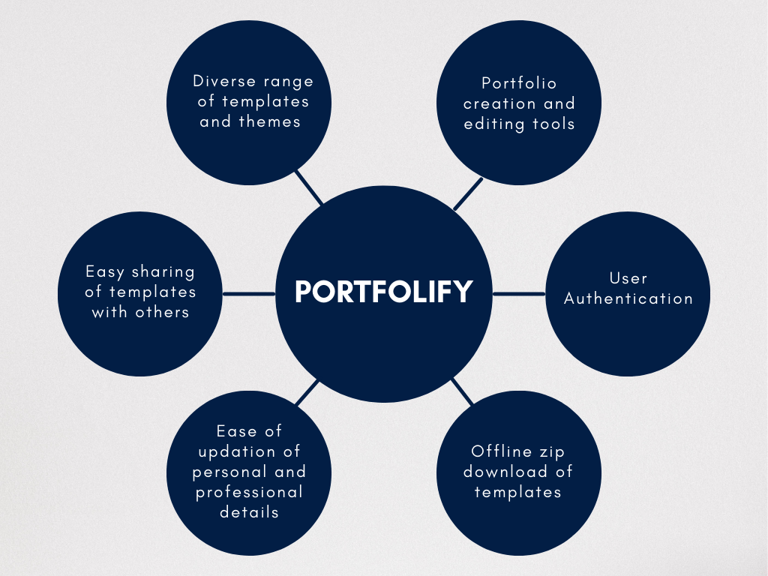

**Features**

* User authentication and profile management.
* Portfolio creation and editing tools.
* Diverse range of templates and themes.
* Ability to download offline portfolio copy

**Scope**

* Initial release will focus on core features of portfolio creation, editing, and sharing.
* Advanced features like custom domains and e-commerce integration will be included in future updates.
* Mobile responsiveness will be prioritized to ensure usability across devices.
* Integration with popular creative tools like Adobe Creative Suite and Sketch may be explored in future releases.

**METHODOLOGY USED**

Agile methodology is a project management approach that prioritizes cross-functional collaboration and continuous improvement. It divides projects into smaller phases and guides teams through cycles of planning, execution, and evaluation.

Few of the main points of Agile Methodology are:

* Individuals and interactions over processes and tools.
* Responding to change over following a plan.

As we are a team with four members, cross communication is a must because there will be a lot of changes since feedback will come from all four members, so our methodology must be centered on making changes as per demand. This is why we chose Agile Methodology as it satisfies our needs the best.

Some features of Agile Methodology are:

* **Rapid progress:** By effectively reducing the time it takes to complete various stages of a project, teams can elicit feedback in real time and produce working prototypes or demos throughout the process.
* **Continuous improvement:** As an iterative approach, agile project management allows teams to chip away at tasks until they reach the best end result.

The Agile software development life cycle consists of six stages, namely:

1. **Concept:** Define the project scope and priorities.
2. **Inception:** Build the Agile team according to project requirements.
3. **Iteration:** Create code factoring in a cross communication among team members.
4. **Release:** Test the code and troubleshoot any issues.
5. **Maintenance:** Provide ongoing support to ensure the product remains serviceable.
6. **Retirement:** The end of the product lifespan, which often coincides with the beginning of a new one.

**STAKEHOLDERS**

In the context of a portfolio builder website, stakeholders are individuals or groups that have an interest in the system, its features, and its outcomes. The major stakeholder of the above mentioned system are Users.

**1. Users:**

The user is the major stakeholder of the system. The user interacts with the system and uses its functionalities in order to generate their portfolio and update relevant details. The user provides information including their personal details, educational background, industry experience, projects and their skills. The user can select from the variety of templates to use and generate their own custom portfolio.

Thus in summary, they are the main drivers of the system. They are responsible for filling in their details and generating their portfolios.

**REQUIREMENT ANALYSIS**

**Functional Requirements**

* User Registration and Authentication.
* Portfolio Creation and Editing.
* Template and Theme Selection.
* Offline zip file download of portfolio.
* Sharing of portfolios with others.

**Non-functional Requirements**

* Performance: Fast loading times and responsiveness across devices.
* Security: Protection against data breaches and cyber-attacks.
* Usability: Intuitive user interface with clear navigation and instructions.
* Scalability: Ability to handle increasing traffic and user growth.
* Compatibility: Support for modern web browsers and mobile devices.

**Constraints**

* Budget Limitations: Development costs should be kept within the allocated budget.
* Technology Restrictions: Compatibility with existing technologies and frameworks.
* Legal Requirements: Compliance with data protection laws and regulations (e.g., GDPR).

In conclusion, portfolio builder should meet these requirements to provide users with a comprehensive solution for building their portfolios effectively and efficiently.

**3.SYSTEM DESIGN**

**FEASIBILITY STUDY**

The feasibility study is a major factor which contributes to the analysis of the system. The decision of the system analysis, whether to design a particular system or not depends on feasibility study. The feasibility study on the system is divided into the following three areas:

1. **OPEARATIONAL FEASIBILITY:**

* The system is user-friendly.
* The short description of the method to operate the new system.
* Assessing the resources necessary to support the system, such as hardware and personnel, and ensuring that these resources are available in order to properly implement the system

1. **TECHNICAL FEASIBILITY:**

* This project is designed with use of the most efficient Software available.
* Effective system design and able to meet user requirements
* Platform independent and uses latest software
* WebApp
* Reduces paper work using database

**III ECONOMICAL FEASIBILITY:**

* Developed using various open source software.
* There is no need of any extra software or plug-ins to run the system.
* The software is cost effective.

**SYSTEM MODEL: USING OOSE**

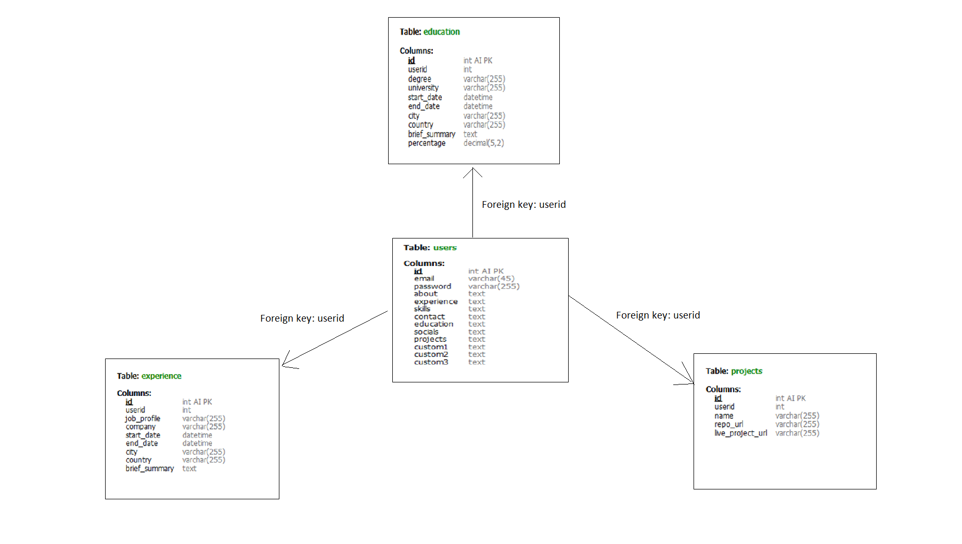

**4.DIAGRAMS**

**System Flow Diagram**

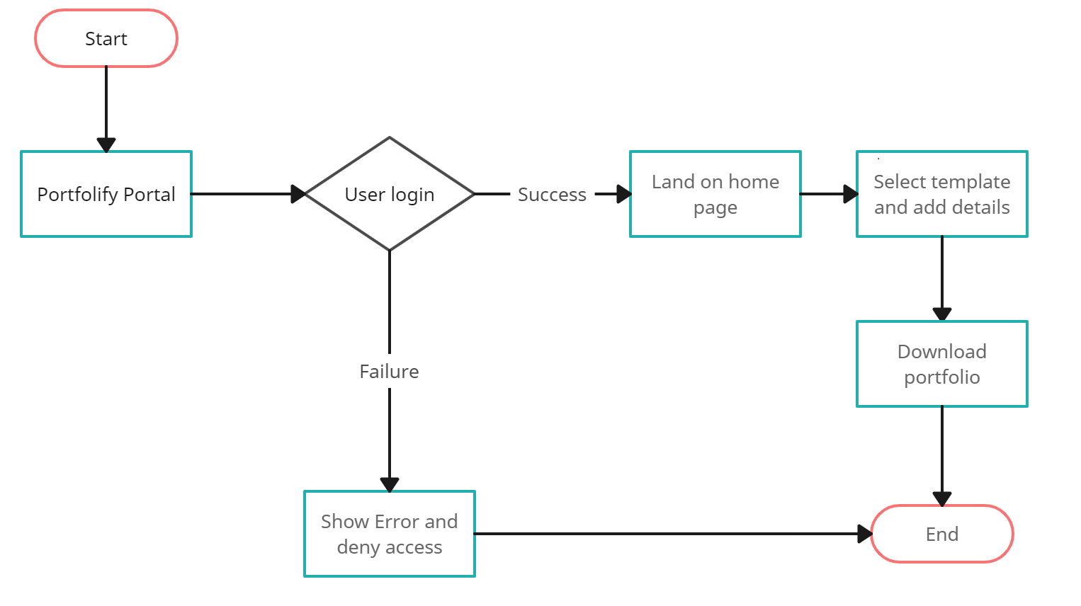

**UserFlowDiagram**:

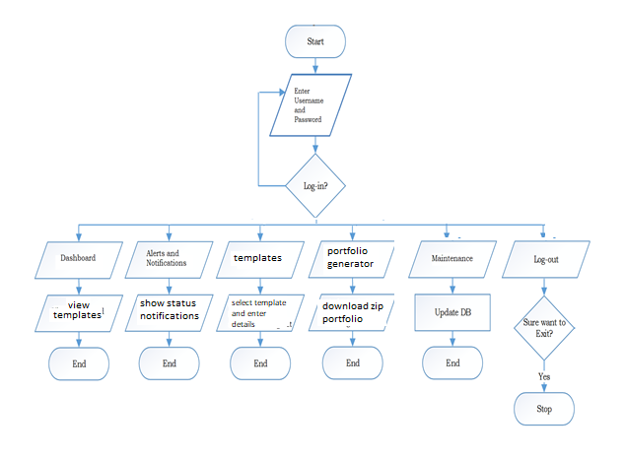

**Activity Diagram for User Login**:

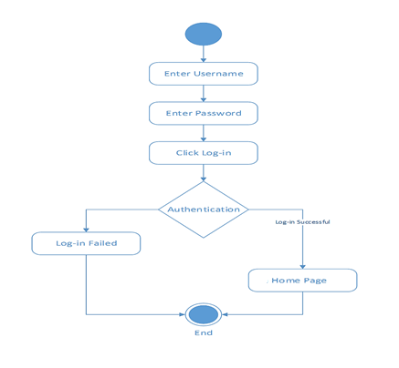

|  |  |
| --- | --- |
| Activity Diagram for Personal details collection | Activity Diagram for Educational details collection |

|  |  |
| --- | --- |
| Activity Diagram for Experience detail collection | Activity Diagram for Project details collection |

Activity Diagram for Certificate Distribution System module, for end user:

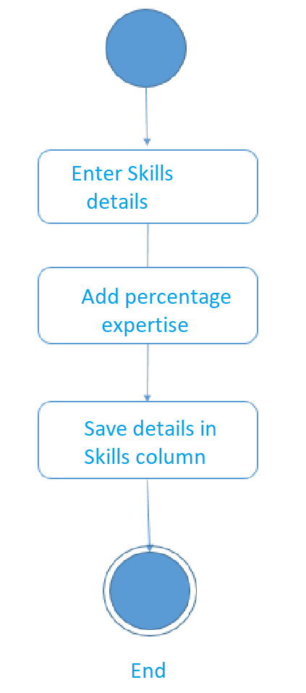

Sequence Diagram for User Login:

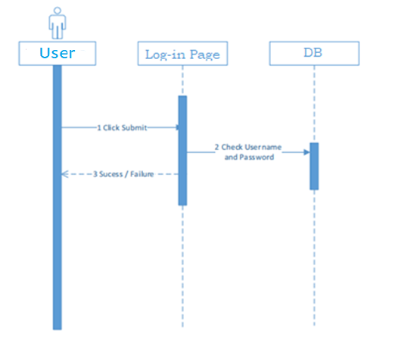

**Use Case Diagram:**

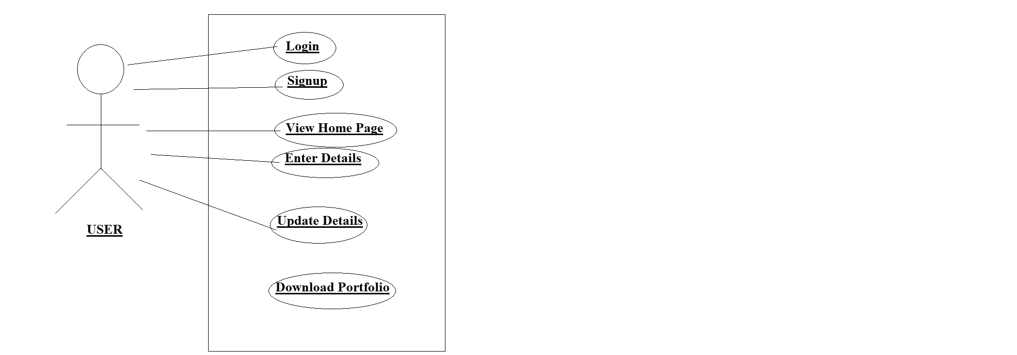

**Package Diagram:**

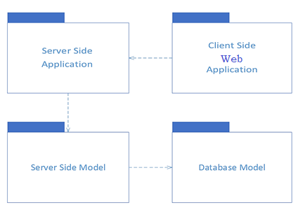

**ER Diagram**

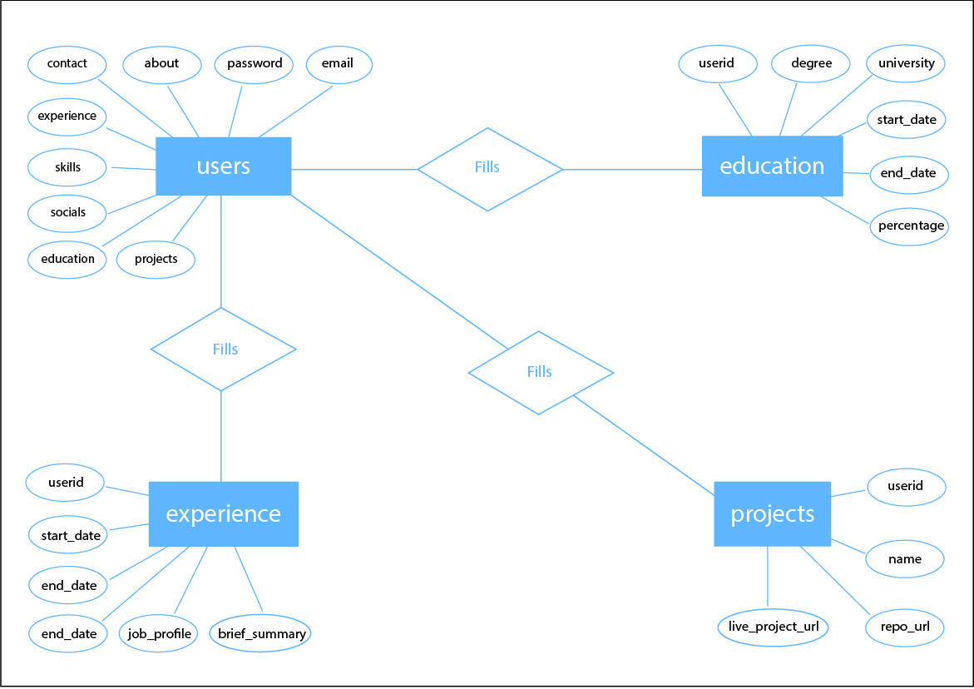

**DATA FLOW DIAGRAM (DFD)**

Level 0 diagram:

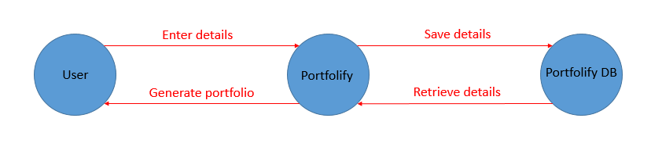

Level 1 diagram:

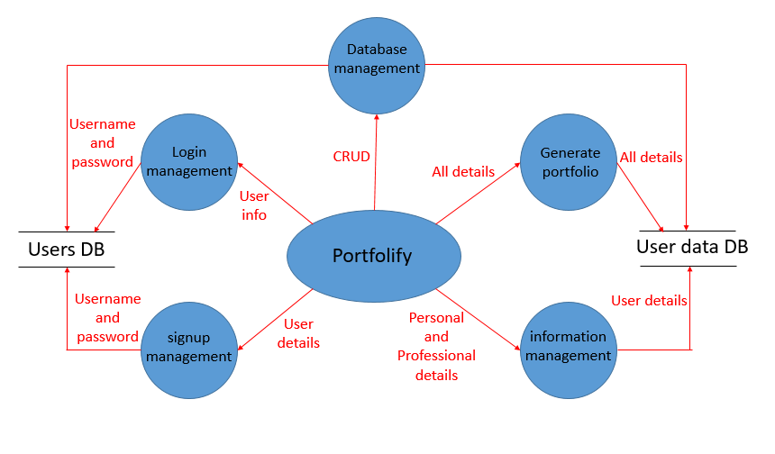

Level 2 diagram:

1: User

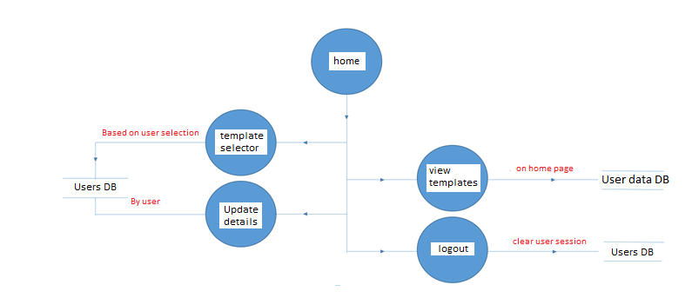

2: Portfolio Generation

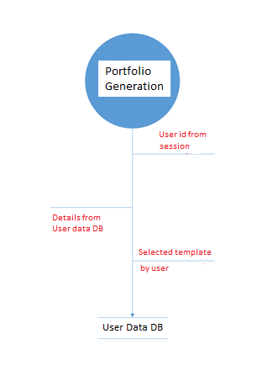

**DATABASE DESIGNING**

1. Users DB

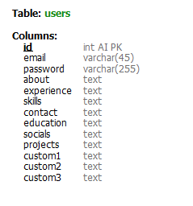

2. Education DB

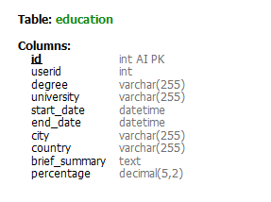

3. Experience DB

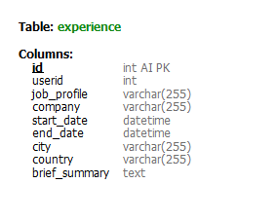

1. Projects DB

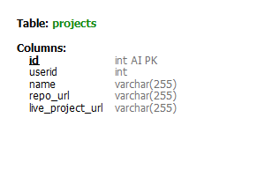

**SCREEN DESIGNING**

User signup:

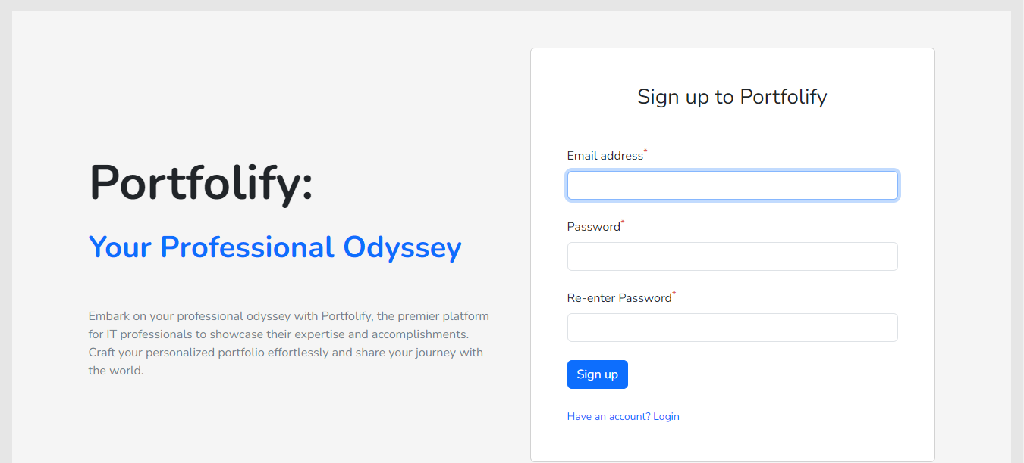

User Login:

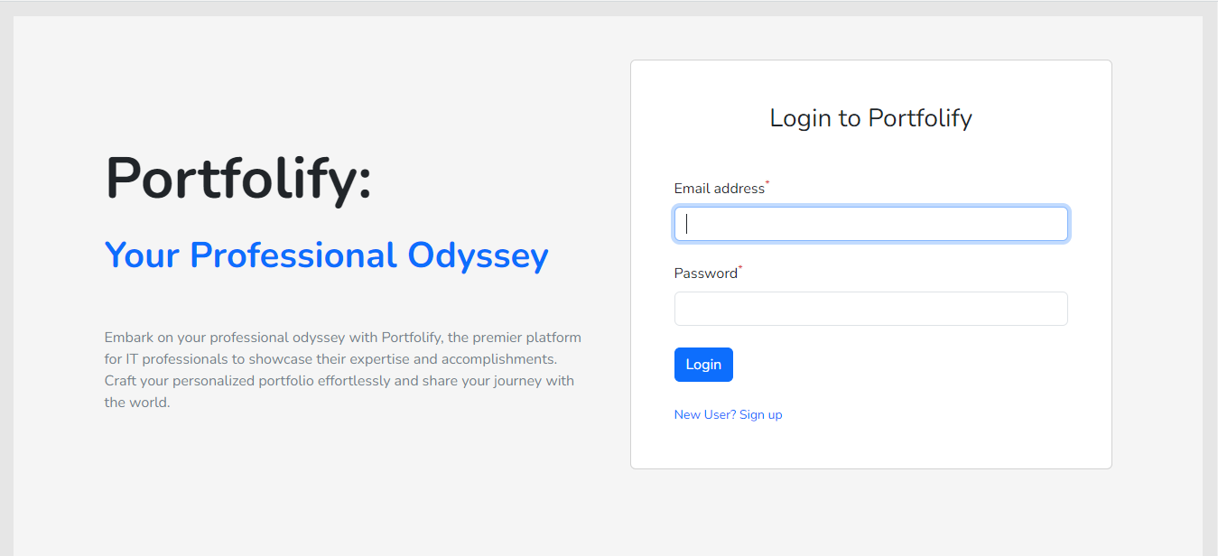

Home Page:

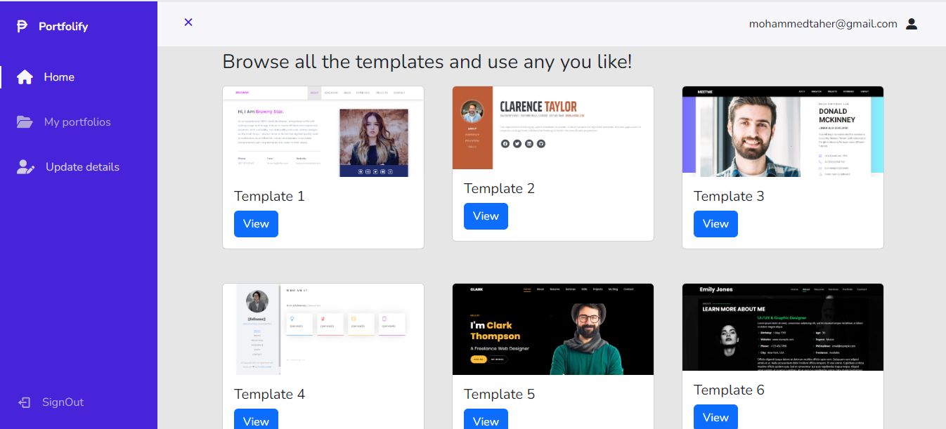

A sample portfolio template:

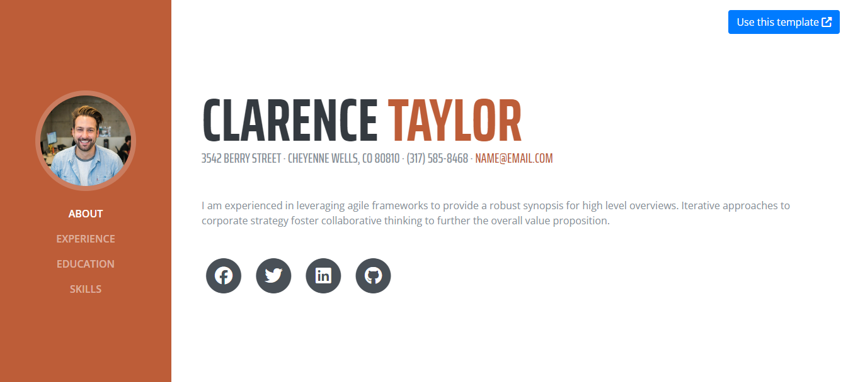

Details page:

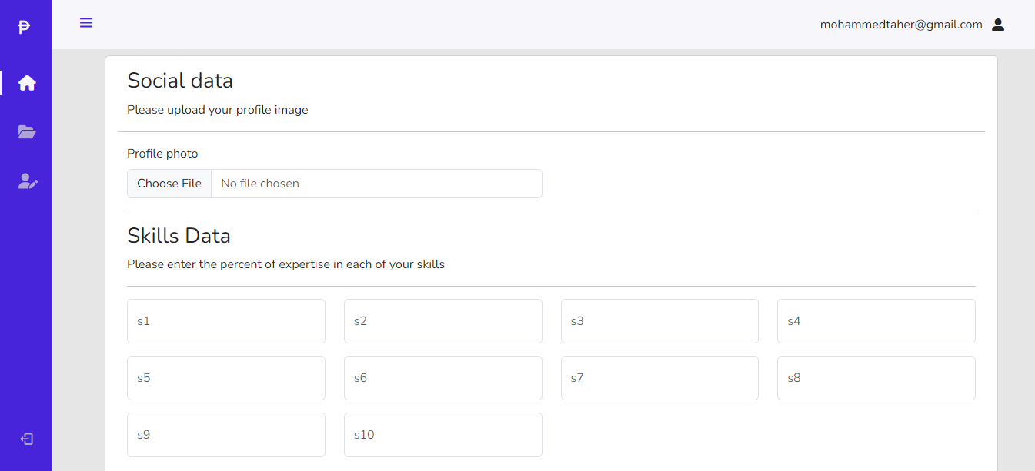

Update details page:

1. Personal details

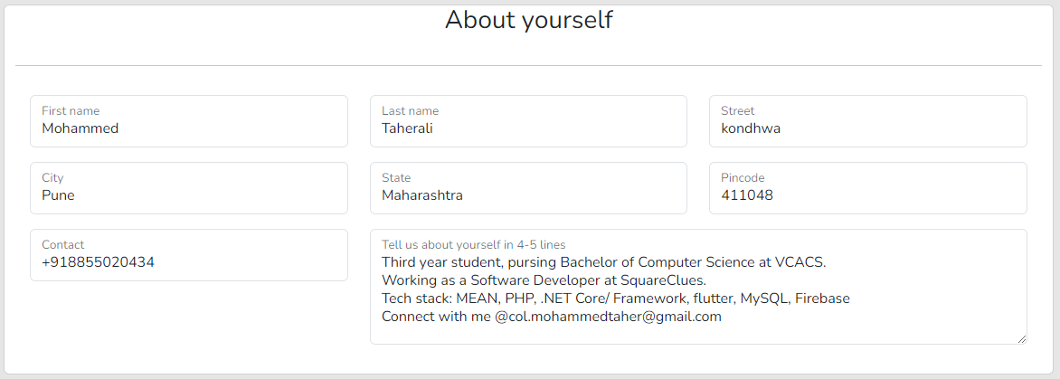

1. Social Details

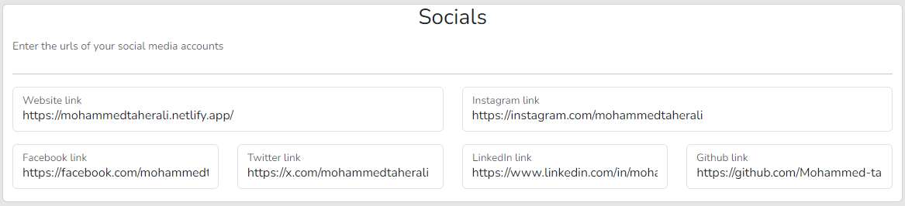

1. Experience Details

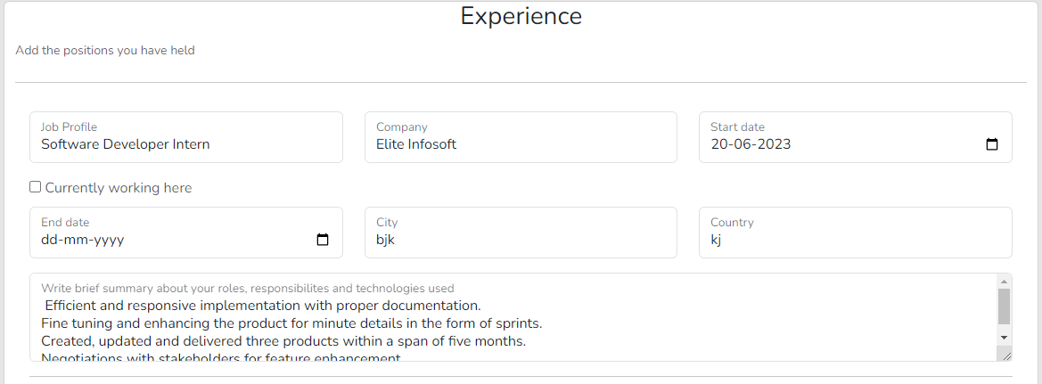

1. Educational Details

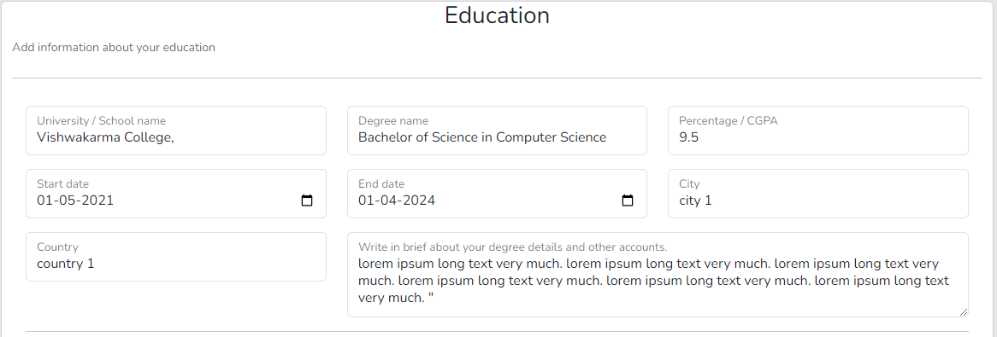

1. Project details

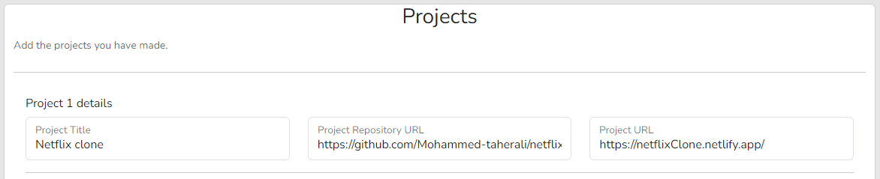

1. Skills Details

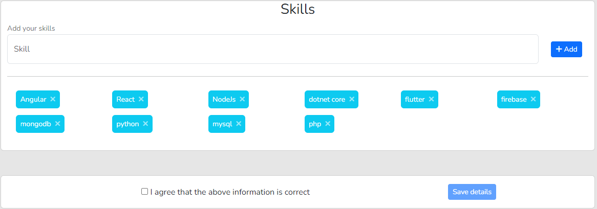

Dynamically created Portfolio:

1. About section

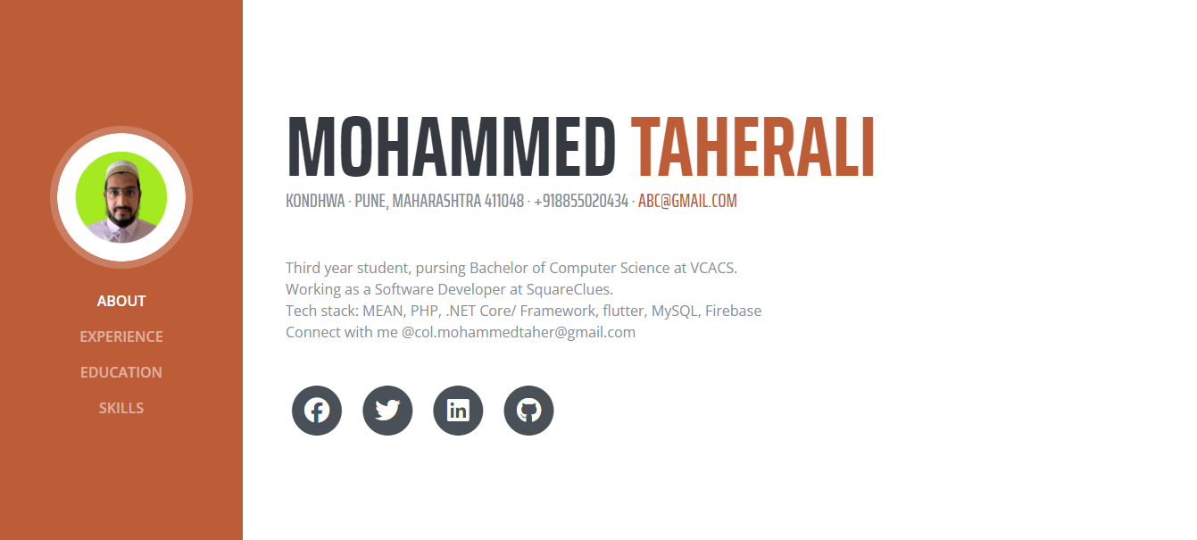

1. Experience section

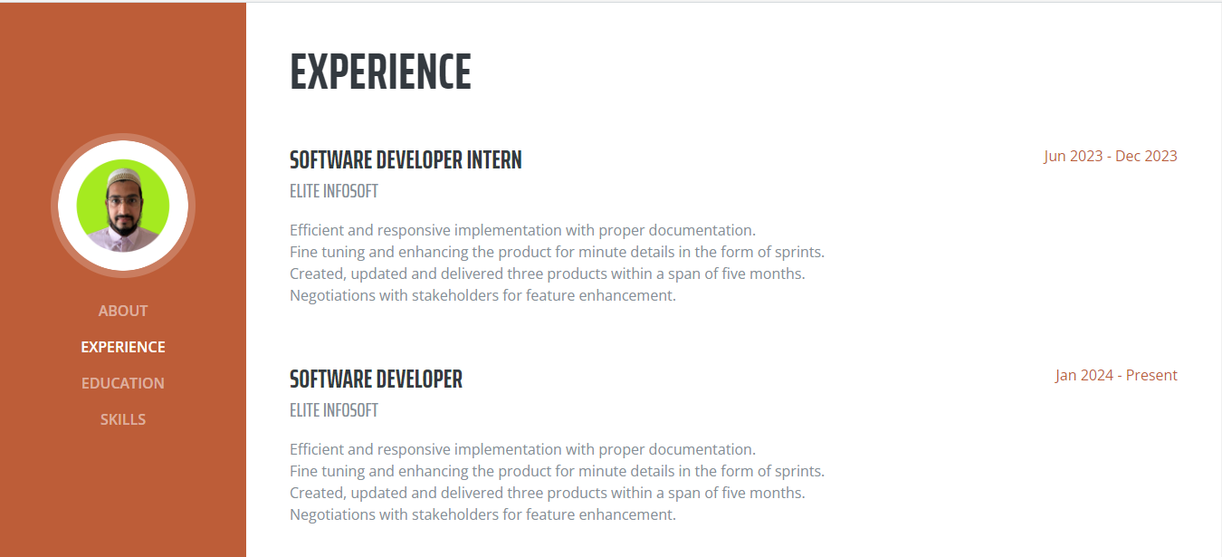

1. Education section

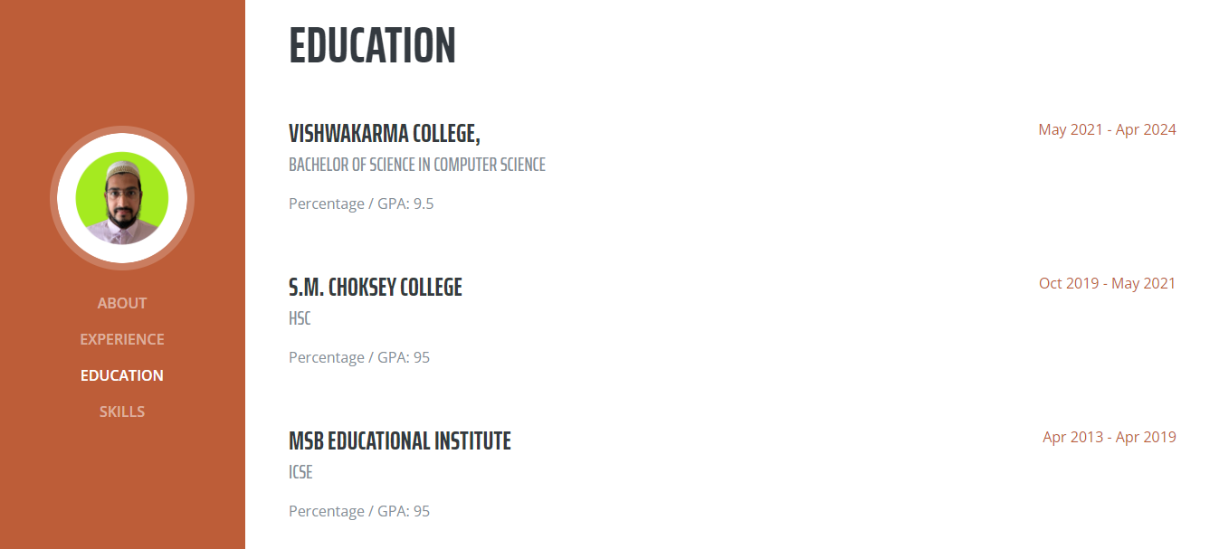

1. Skills section

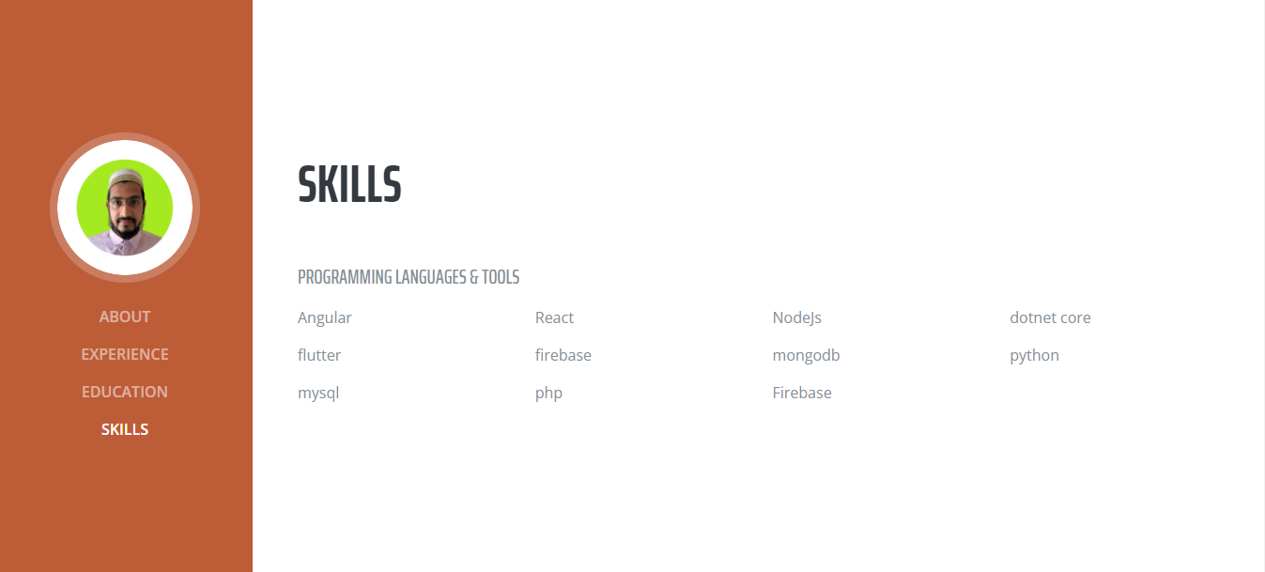

Success notification:

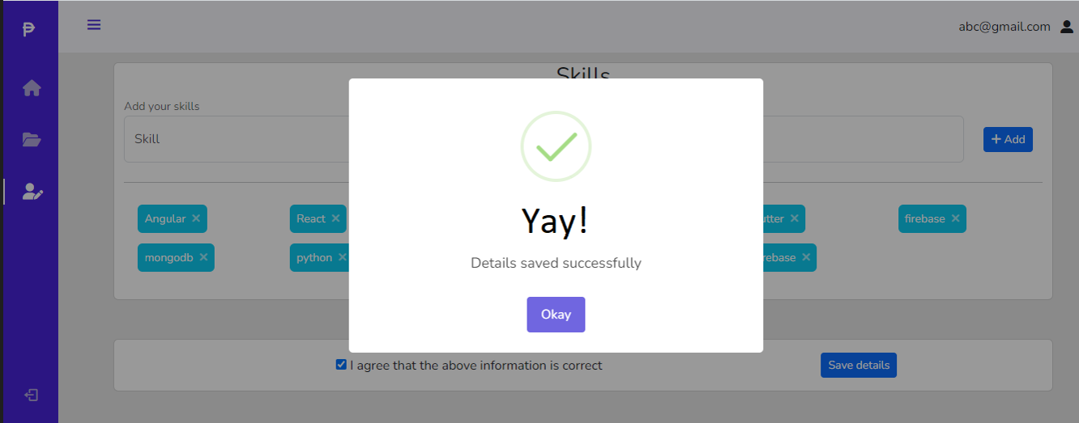

**5.IMPLEMENTATION DETAILS**

**HARDWARE AND SOFTWARE REQUIREMENTS**

For “**Portfolify:** Your portfolio builder”, we have selected the following hardware and software.

**HARDWARE SELECTION:**

* Processor : Intel(R) Core(TM) i3-4005U CPU @ 1.70GHz
* RAM : 4.00 GB
* SDD : 128 GB
* System type : 64-bit operating system, x64-based processor
* Device : Any web browser

**SOFTWARE SELECTION:**

* Front End : HTML, CSS, JS, PHP 7.2
* Back End : MySQL (Version 5)
* Operating System : Windows 10 Pro/Linux
* Web Server : Microsoft IIS 7.x / WAMP Apache

**6.OUTPUTS AND REPORT TESTING**

**BLACK BOX TESTING**

The following black box testing was done for Portfolify:

* **Test Cases**: Black box testing involves creating test cases based on the system's requirements and specifications. These test cases should cover all the system's functionalities, such as Login, signup, enter details, update details, generate portfolio.
* **Test Data**: Black box testing requires appropriate test data that simulates real-life scenarios, such as various types of users with different experience, educational backgrounds and projects. The test data should cover all possible scenarios to ensure that the system functions as expected.
* **Test Techniques**: Black box testing involves using various test techniques, such as boundary value analysis, equivalence partitioning, and decision table testing. These techniques are used to ensure that the system handles different types of inputs and outputs correctly and efficiently.
* **User Interface Testing**: Black box testing also involves testing the system's user interface (UI) and user experience (UX), to ensure that the system is easy to use and navigate. This testing should verify that the system's UI/UX design is user-friendly and meets the expectations of event planners and attendees.
* **Regression Testing**: Black box testing also involves performing regression testing, which is the process of retesting the system after modifications or changes have been made. Regression testing ensures that the system still works correctly after changes have been made.
* **Test Reports**: Black box testing generates test reports that document the test cases executed, the results obtained, and any issues encountered. These reports help stakeholders understand the system's current status and the progress made in resolving any issues.

**WHITE BOX TESTING**

The following white box testing was done for Portfolify:

* **Test Coverage**: White box testing aims to achieve maximum test coverage by testing all possible code paths, including statements, branches, and conditions.
* **Test Techniques**: White box testing involves using various test techniques, such as unit testing, integration testing, and system testing. These techniques were used to ensure that the system's components and modules work together correctly and efficiently.
* **Performance Testing**: White box testing also involves performance testing, which verifies that the system can handle a large number of events and attendees without performance degradation.
* **Security Testing**: This testing should ensure that the system's data is secure, and no unauthorized access or modifications can be made.
* **Code Reviews**: White box testing also involves code reviews, which are the process of reviewing the system's codebase for code quality, maintainability, and adherence to coding standards. Code reviews help identify potential issues early in the development cycle, reducing the likelihood of bugs and defects in the system.
* **Test Reports**: White box testing generates test reports that document the test cases executed, the results obtained, and any issues encountered. These reports help stakeholders understand the system's current status and the progress made in resolving any issues.

**TEST SCOPE**

The following are some key areas that the test scope for Portfolify covers:

* **Functionality Testing**: This involves testing the system's core functionalities, such as login, signup, entering details, updating details, and generatinga portfolio. The testing should verify that the system is functioning as expected and meets the requirements stated in the requirement analysis.
* **Usability Testing**: This involves testing the system's user interface (UI) and user experience (UX), to ensure that the system is easy to use and navigate.
* **Performance Testing**: This involves testing the system's performance, such as its speed, response time, and scalability. The testing should verify that the system can handle a large number of attendees, transactions, and data, without compromising its performance.
* **Security Testing**: This involves testing the system's security, such as its ability to prevent unauthorized access, data breaches, and other security threats.
* **Compatibility Testing**: This involves testing the system's compatibility with different operating systems, browsers, and devices.
* **Integration Testing**: This involves testing the system's integration with other third-party systems, such as payment gateways, email marketing tools, and social media platforms. The testing should verify that the system can integrate with these systems seamlessly and without any issues.

In conclusion, the test scope for a portfolio building software should cover various aspects of the system, including functionality, usability, performance, security, compatibility, and integration. Testing should be thorough and rigorous to ensure that the system meets the requirements and expectations of event planners and attendees.

|  |  |  |  |  |  |  |  |
| --- | --- | --- | --- | --- | --- | --- | --- |
| **Test Cases** | | | | | | | |
| Test Case ID | Test Case Name | Test Case Description | Test Steps | | | | Test Status  Pass/Fail |
| Step | Input | Expected Output | Actual Output |
| Test Case 1 | Login | To verify that the user has entered valid email and password | Login with email and Password | Username:  User@gmail.com  Password:  Password  (valid) | Home.php page should be displayed | Login successful | Pass |
|  | Login | To verify that the admin has entered invalid username and password | Login with email and Password | Username:  user  Password:  password  (Invalid email) | Shows Error message: Invalid email format | Login failed | Pass |
| Test case 2 | Signup | To verify email and password are valid | Signup with valid email and password | Username:  User@gmail.com  Password:  Password  (valid) | User should be directed to info.php page to fill up details. | Signup successful | Pass |
|  | Signup | To verify password and confirm password entered are same | Enter same password and confirm password value | Password:  password  confirm password:  password | Direct user to info.php page | Signup successful | Pass |

|  |  |  |  |  |  |  |  |
| --- | --- | --- | --- | --- | --- | --- | --- |
| Test Case 3 | Details page | To enter user details | Enter all valid details accordingly | Valid Details | Save the details in Database | The details are saved in the database | Pass |
|  | Details page | To Enter user details in incorrect format | Enter all invalid details | Invalid Details | Shows error message to user. | Details are not stored in the database | Pass |
|  | Download portfolio | User clicks generate portfolio button after entering correct details | Click on button | Click | Downloads the portfolio in the form of a zip folder | Portfolio is downloaded locally | Pass |

**7.CONCLUSION**

In conclusion, the development of a user friendly, simple portfolio builder will be an excellent tool for the common user considering the technological advances we have made.

The website can simplify the process of making a portfolio, all done through guided explanations using proper placeholders and data type, our websites comes along with a variety of templates which is going to improve the users’ experience, the templates are suited to most users need as it is flexible in what type of portfolio they can make. Without any prior experience of making a portfolio a beginner could make their own portfolio all the while making it proper, well-formatted, appealing and attractive.

With the continued growth of all the technological advancements we have in the 21st century a portfolio is a must-have for any techie looking to further their skills or find a job.

**LIMITATIONS**

The limitations of our current website are:

* The users are still restricted to use a limited amount of templates to choose from.
* No contact information of developers in case of a problem.
* Slow speed due to lack of optimization in website.
* Not as responsive as needed.
* Not optimized for mobile devices.
* Database not completely optimized.
* Website is not safeguarded from DDOS attacks.

**PURPOSED ENHANCEMENTS**

Our team has planned several enhancements for the websites such as:

* Increasing the UI friendliness of the website.
* Making the website optimized for mobile devices.
* Adding more templates for freedom of choice.
* Adding fonts to change the way a portfolio looks.
* Making sure the website is safe from DDOS attacks by purchasing services such as Cloudflare which mostly prevent DDOS attacks.
* Adding a human verification such as CAPTCHA to prevent bot raids.
* Increasing the responsiveness of the website.
* Increasing load speed by cleaning and optimizing codes.
* Solidifying our Database to welcome any amount of data for storage.
* Providing contact information in case of discrepancy.

**8.FUTURE SCOPE OF THE SYSTEM**

The future of portfolios seem bright as it is pretty recent and is welcomed by corporations and individual users alike, it allows a consumer to get a first impression on the maker of the portfolio and give them a brief introduction to their skills which is very important in today’s age since many companies are short on time for recruitment and opt for the most abstract, well-made and simple looking portfolio.

With the rise of virtual age portfolios will provide a brief view into a person, a sort of digital introduction, one that is very precise, concise, proper and formatted. These will grow increasingly popular as the demand for easier way to get to know a person will be needed, no more will there be a need for paper or letters to introduce oneself, not even a face to face conversation, all can be done digitally at one’s own free time which will make it incredibly useful and a crucial part of our life.

Overall, the portfolio making systems will become an integral part of our lives and the popularity will continue to grow and evolve for very long time to come as users will realize the importance to having a well maintained portfolio.

**9.BIBLIOGRAPHY**

* Google [https://www.google.com/]
* Stack Overflow [https://stackoverflow.com/]
* W3Schools [https://www.w3schools.com/]
* Javatpoint [https://www.javatpoint.com/]
* GeeksforGeeks [https://www.geeksforgeeks.org/]
* HubSpot Blog [https://blog.hubspot.com/]
* Microsoft [https://www.microsoft.com/]
* Web Technology reference books
* HTML reference books
* PHP reference books
* JavaScript reference books
* Database Management Systems reference books

